Note before development begins

In some cases, the bootloader onboard gets corrupted, the symptom is Arduino IDE could not write new sketch by USB, or new written sketch could not take effect. This might caused by the process of UF2 firmware gets interrupted somehow, right after uploading, during populating the new sketch into FLASH, but it’s hard to reproduce the process and the exact cause is unknown.

To unbrick the board, re-flash the bootloader is required, an SWD interface dongle is required to do this. The connection of SWD interface needs only two signal wires, SWDIO and SWDCLK, but to successfully talk to SWD interface, VDD from Target is also required, for SWD to detect Target connection (VDD).

Why choose this board
PCA10056 (nRF52840 Development Kit) is the official DK from Nordic Semi, comes with all IOs fanned out, and comes with a J-link Debugger (SWD). nRF52840 has an integrated USB port, which could run directly on USB 5V supply. With 1MB flash and 256KB RAM, to run Arduino code without concerns.

The onboard SWD debugger on nRF52840 Development Kit can also be used to debug external nRF devices, it has sophisticated circuit design to protect your testing target and itself, and this process is automatic. Since DK board already has a nRF52840 onboard, to make sure you have external target connected is being flashed rather than the onboard one, unfortunately there’s no hard switch, it has to be relied on its automatic switch. But after flashing, re-reading FLASH content mapping is possible. To make sure you have flashed the right chip, leaving onboard MCU FLASH blank is a good practice.

Arduino Board Port
Develop firmware on nRF52840 has many ways, official SDK has a steep learning curve and have many version numbers, but running Arduino is also possible, it has been done by Adafruit.

There’re two parts of work to run Arduino, one part is the compiler and BSP files resides in Arduino IDE, the other part is the bootloader on nRF5 chip. Corresponding github links:

- https://github.com/adafruit/Adafruit_nRF52_Arduino
- https://github.com/adafruit/Adafruit_nRF52_Bootloader

Documents from these repos are good starting point, just copy and update some board files have successfully tested the Hat hardware, and fully functional.

One last thing about flashing bootloader on a blank nrf52840 chip, or just rewrite/update over existed bootloader, the Bug board needs to be connected with both USB (from battery power source, no host USB), and SWD cable to nRF52840 DK board on upper left P19 socket. DK board need to connected to a PC with nRF Connect for Desktop → Programmer application, and restart DK board by sliding ON/OFF switch on down left corner, to make sure external SWD target is connected. Quick summary:
- Install nRF Connect for Desktop, install Programmer inside the Desktop app
- Connect DK board then choose board, make sure it works
- Connect the Bug SWD to DK board, USB to a power only source, reboot DK board (switch)
- Re-choose the target from Programmer app, choose bootloader file, flash.
- Re-read target flash content by removing (hot unplug the Hat’s SWD cable) ensure flashed.

Fig1. choose and install programmer to flash the bootloader)
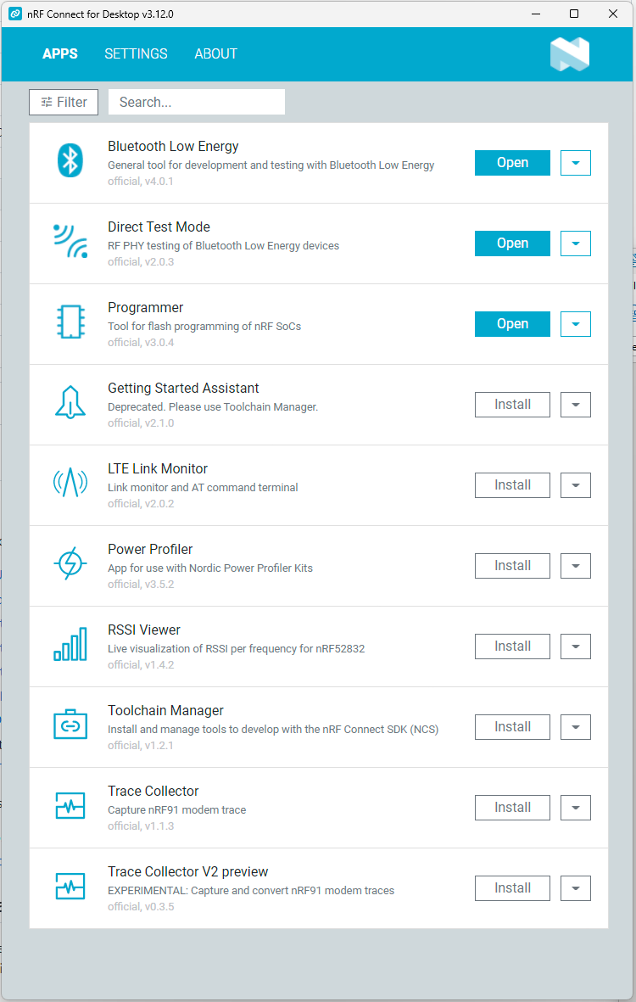
Fig2. A. Choose device on upper left corner, B. Choose bootloader .HEX file then click Erase & Write
Fig3. Read FLASH content mapping to make sure flashed the right nRF52840 chip.

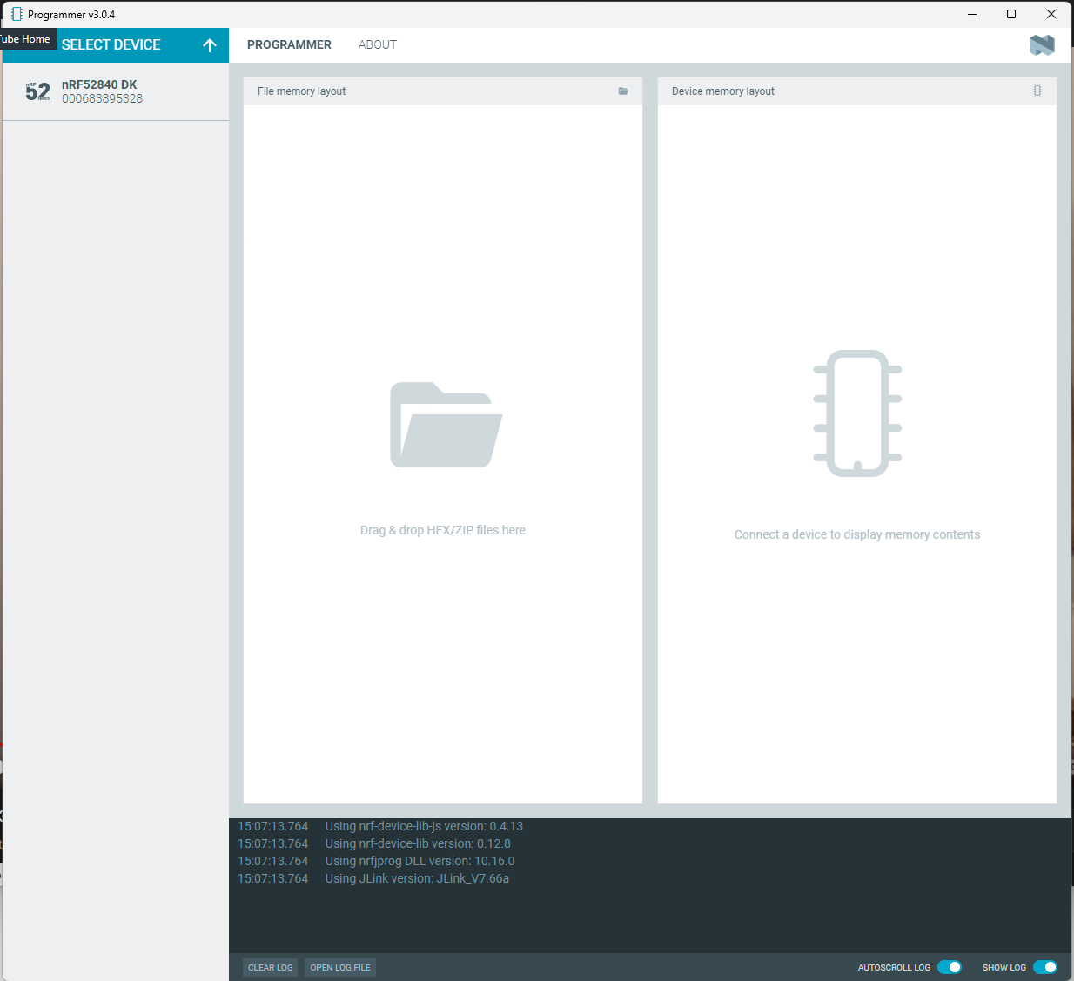
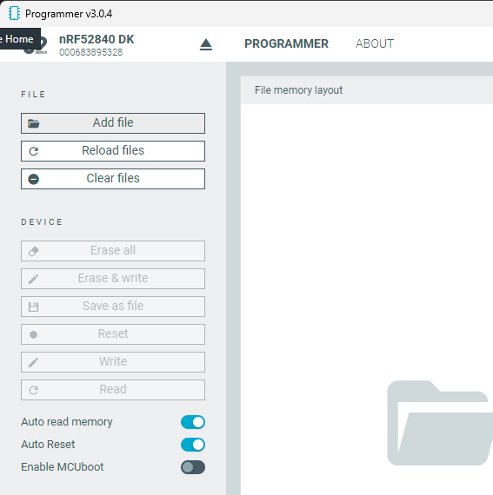
Fig1: When Programmer app is installed the button turns blue.
Fig2: Left column and eject button to choose SWD device interface.

Fig3: Hex file mapping address vs FLASH content mapping address (no file loaded in picture, if FLASH is blank, mapping table will be all grey)
